Cbcs

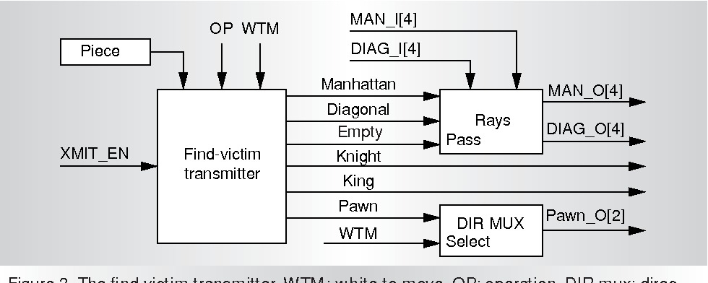1a

1b )

Working process :

The Deep Blue algorithm is separated into three layers: out of many SP processors, one acts as a master, and the other two as workers. The master processor's job is to search the top levels of the chess game tree and hand over the results - often called "leaf positions"- to the workers for further examination. Now, workers carry out additional searches and distribute leaf positions to the chess chips. Finally, chess chips extend the search to the last few levels of the game tree.

While performing all these activities, the speed of the system also varies. For example, tactical positions - when long and forcing moves are required, the deep blue algorithm can explore up to 100 million positions per second. On the other hand, for quieter positions, the search could go up to 200 million positions per second. It is said that in 1997 match with Garry Kasparov, the minimum search speed was 126 million positions per second, and the maximum number of the search speed was 330 million positions per second.

**COMPONENTS OF DEEP BLUE ALGORITHM**

* **Move Generation:**The Deep Blue algorithm has numbers of other functions like generation of checking, check evasion moves, and developing certain kinds of attacking moves. Besides, chess chips also support several search extensions, which is made possible by the move generator. It's an 8 X 8 array of combinatorial logic acting as a silicon chessboard. However, the move generator generates a single move at a time but it calculates all the possible moves and selects the most significant one with the help of an arbitration network.
* **Evaluation Function:** The evaluation function is composed of fast evaluation and slow evaluation. These standard techniques are used to save the system from running an expensive search where a simple approximation is required. The fast evaluation computes the score on the basis of the position of a particular piece in a single clock cycle. Contrary, the slow evaluation scans the chess board’s each column at a time. For example, it computes the values of chess concepts such as square control, king safety, pawn structure, pawn majority, restraint, color complex, trapped pieces, development, etc.
* **Search Control:** The Deep Blue chess chip contains the null-window alpha-beta search. The best part of the chip is it averts the need for a value stack, thus simplifying the board design. However, there are some disadvantages too like in some cases it requires multiple searches and the lack of transposition table that increases the search efficiency. The search algorithm needs a move stack-a repetition detector to keep track of the previous moves up to the last 32 positions.
* **Extendability:** The chess chip also supports the use of external Field Programmable Gate Array (FPGA) to give access to the external transpositional table, complex search control, and additional terms for the evaluation function. The main aim of this function is to address the complexity of the mechanism and make it efficient. Null move search is also supported by this system but due to time constraints, this was never used in Deep Blue.

2a) alpha go

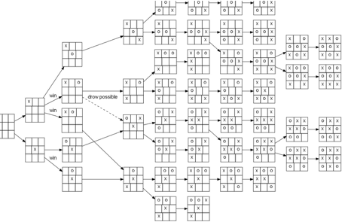

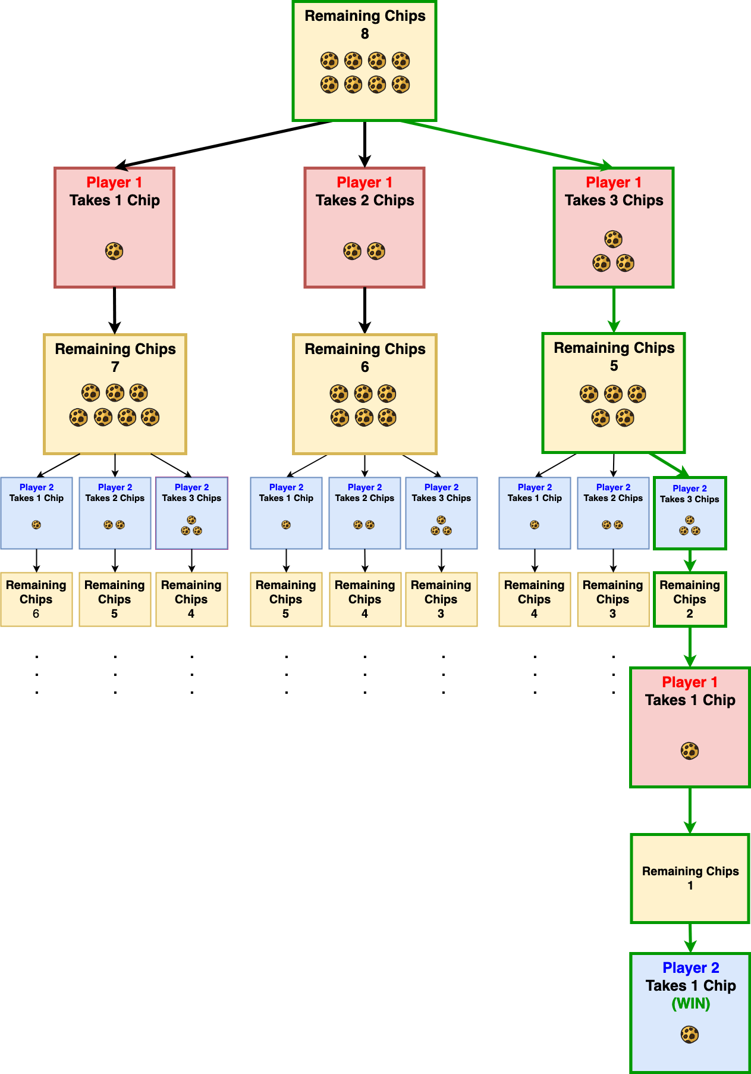

2b)

The AlphaGo, a computer program that combines advanced search tree with deep neural networks. These neural networks take a description of the Go board as an input and process it through a number of different network layers containing millions of neuron-like connections.

One neural network, the “policy network”, selects the next move to play. The other neural network, the “value network”, predicts the winner of the game.

The AlphaGo to numerous amateur games to help it develop an understanding of reasonable human play. Then It was played against different versions of itself thousands of times, each time learning from its mistakes.

Over time, AlphaGo improved and became increasingly stronger and better at learning and decision-making. This process is known as reinforcement learning.

3 )

Simple Reflex agent:

* The Simple reflex agents are the simplest agents. These agents take decisions on the basis of the current percepts and ignore the rest of the percept history.
* These agents only succeed in the fully observable environment.
* The Simple reflex agent does not consider any part of percepts history during their decision and action process.
* The Simple reflex agent works on Condition-action rule, which means it maps the current state to action. Such as a Room Cleaner agent, it works only if there is dirt in the room.
* Problems for the simple reflex agent design approach:
  + They have very limited intelligence
  + They do not have knowledge of non-perceptual parts of the current state
  + Mostly too big to generate and to store.
  + Not adaptive to changes in the environment.

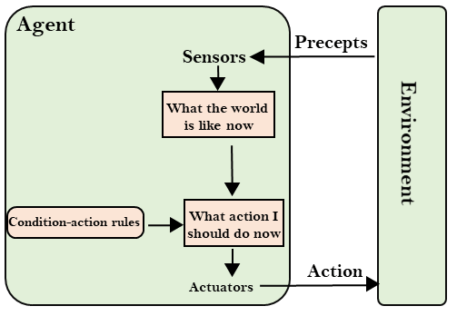

Model-based agent

* The Model-based agent can work in a partially observable environment, and track the situation.
* A model-based agent has two important factors:
  + **Model:** It is knowledge about "how things happen in the world," so it is called a Model-based agent.
  + **Internal State:** It is a representation of the current state based on percept history.
* These agents have the model, "which is knowledge of the world" and based on the model they perform actions.
* Updating the agent state requires information about:
  + How the world evolves
  + How the agent's action affects the world.

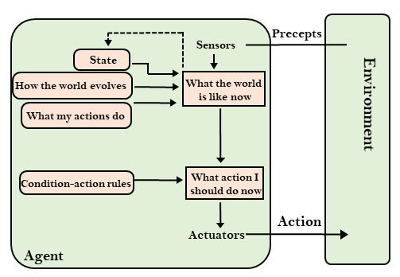

4a )

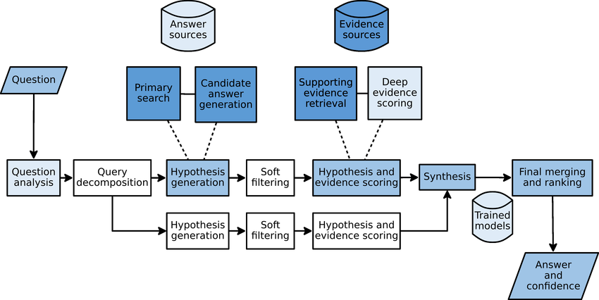

Watson uses IBM’s DeepQA technology (over optimized IBM POWER7 servers) to analyze and produce a Jeopardy! clue response. Those responses come with an associated confidence, or estimated probability that the answer is correct. If his confidence is high enough, Watson may decide to buzz in. To do this, Watson sends a signal to a mechanical thumb, which is mounted on exactly the same type of Jeopardy! buzzer used by human contestants.Watson must physically depress a button to buzz in.

Watson’s buzzing is not instantaneous. For some clues he may not complete the question answering computation in time to make the decision to buzz in. For all clues, even if he does have an answer and confidence ready in time, he still has to respond to the signal and physically depress the button.

The best human contestants don’t wait for, but instead anticipate when hunma will finish reading a clue. They time their “buzz” for the instant when the last word leaves human mouth and the “Buzzer Enable” light turns on. Watson cannot anticipate. He can only react to the enable signal. While Watson reacts at an impressive speed, humans can and do buzz in faster than his best possible reaction time.

When answering a clue, Watson must convert his answer from text into speech to verbally respond like any other contestant. An operator prompts Watson to speak his answer. The operator has no control over what Watson might say. The operator just ensures that Watson will speak at the right moment and not interrupt the host or others.

The sound of Watson’s voice is synthesized, based on a human’s voice. Since it’s not possible to record someone speaking every possible word and phrase imaginable – all the more so given the vast range of topics and knowledge that even a single game of Jeopardy! demands – an IBM text-to-speech engine (TTS) “speaks” Watson’s answer. And Watson’s speech must be highly accurate, as mispronunciations of an ambiguous response may be judged incorrect.

Categories and clues

Watson autonomously selects categories and clues, based on algorithms that – just as his human opponents will do – take into consideration available clues; score and game position; knowledge of clues previously revealed, as well as other factors. In the next article of the series, we will take a closer look at how Watson chooses a Jeopardy! category and clue.

## 5 )

## What is Deep Learning?

[Deep learning](https://www.simplilearn.com/tutorials/deep-learning-tutorial/what-is-deep-learning) uses artificial neural networks to perform sophisticated computations on large amounts of data. It is a [type of machine learning](https://www.simplilearn.com/tutorials/machine-learning-tutorial/types-of-machine-learning) that works based on the structure and function of the human brain.

Deep learning algorithms train machines by learning from examples. Industries such as health care, eCommerce, entertainment, and advertising commonly use deep learning.

Convolutional Neural Networks (CNNs)

A convolutional neural network (CNN) is a type of [artificial neural network](https://www.techtarget.com/searchenterpriseai/definition/neural-network) used in [image recognition](https://www.techtarget.com/searchenterpriseai/definition/image-recognition) and processing that is specifically designed to process pixel data.

CNNs are powerful image processing, artificial intelligence ([AI](https://www.techtarget.com/searchenterpriseai/definition/image-recognition)) that use deep learning to perform both generative and descriptive tasks, often using machine vison that includes image and video recognition, along with recommender systems and natural language processing ([NLP](https://www.techtarget.com/searchbusinessanalytics/definition/natural-language-processing-NLP)).

Long Short Term Memory Networks (LSTMs)

Long Short-Term Memory (LSTM) networks are a type of recurrent neural network capable of learning order dependence in sequence prediction problems.

This is a behavior required in complex problem domains like machine translation, speech recognition, and more.

Recurrent Neural Networks (RNNs)

A **recurrent neural network** (**RNN**) is a class of [artificial neural networks](https://en.wikipedia.org/wiki/Artificial_neural_network) where connections between nodes form a [directed](https://en.wikipedia.org/wiki/Directed_graph) or [undirected graph](https://en.wikipedia.org/wiki/Graph_(discrete_mathematics)) along a temporal sequence. This allows it to exhibit temporal dynamic behavior.

Generative Adversarial Networks (GANs)

Generative Adversarial Networks, or GANs for short, are an approach to generative modeling using deep learning methods, such as convolutional neural networks.

Generative modeling is an unsupervised learning task in machine learning that involves automatically discovering and learning the regularities or patterns in input data in such a way that the model can be used to generate or output new examples that plausibly could have been drawn from the original dataset.

Radial Basis Function Networks (RBFNs)

Radial basis function (RBF) networks are a commonly used type of artificial neural network for function approximation problems. Radial basis function networks are distinguished from other neural networks due to their universal approximation and faster learning speed. An RBF network is a type of feed forward neural network composed of three layers, namely the input layer, the hidden layer and the output layer.

Multilayer Perceptrons (MLPs)

A multilayer perceptron (MLP) is a feedforward artificial neural network that generates a set of outputs from a set of inputs. An MLP is characterized by several layers of input nodes connected as a directed graph between the input and output layers. MLP uses backpropogation for training the network. MLP is a deep learning method.

Examples :

## Image recognition

## Speech recognition

## Medical diagnosis

## Statistical arbitrage

Predictive analytics

## Extraction

## 6 question

## Discuss in Detail About the Role of Robotics in Day to Day Life ?

## <https://studiousguy.com/robotics-examples/#:~:text=This%20is%20one%20of%20the,to%20develop%20hi%2Dtech%20cars>.

## Applications of Reinforcement Learning

Here are applications of Reinforcement Learning:

* Robotics for industrial automation.
* Business strategy planning
* [Machine learning](https://www.guru99.com/machine-learning-tutorial.html) and data processing
* It helps you to create training systems that provide custom instruction and materials according to the requirement of students.
* Aircraft control and robot motion control
* Applications in self-driving cars
* Industry automation with Reinforcement Learning
* Reinforcement Learning applications in trading and finance
* Reinforcement Learning in NLP (Natural Language Processing)

Discuss about How Ai is Better than Humans ?